ART285: Interactive Audio Design Assignment 4
Topic: Song Structure Song Analysis

Objectives: At the end of this project, students will be able to:
• Identify the elements of song construction.
• Identify chord progressions, melodies, harmonies, dynamics, and rhythm.
• Analyze lyric structure and vocal arrangement.
• Analyze song structure and identify major components.
• Write about music, using terms like tempo, arrangement, instrumentation, and dynamics.

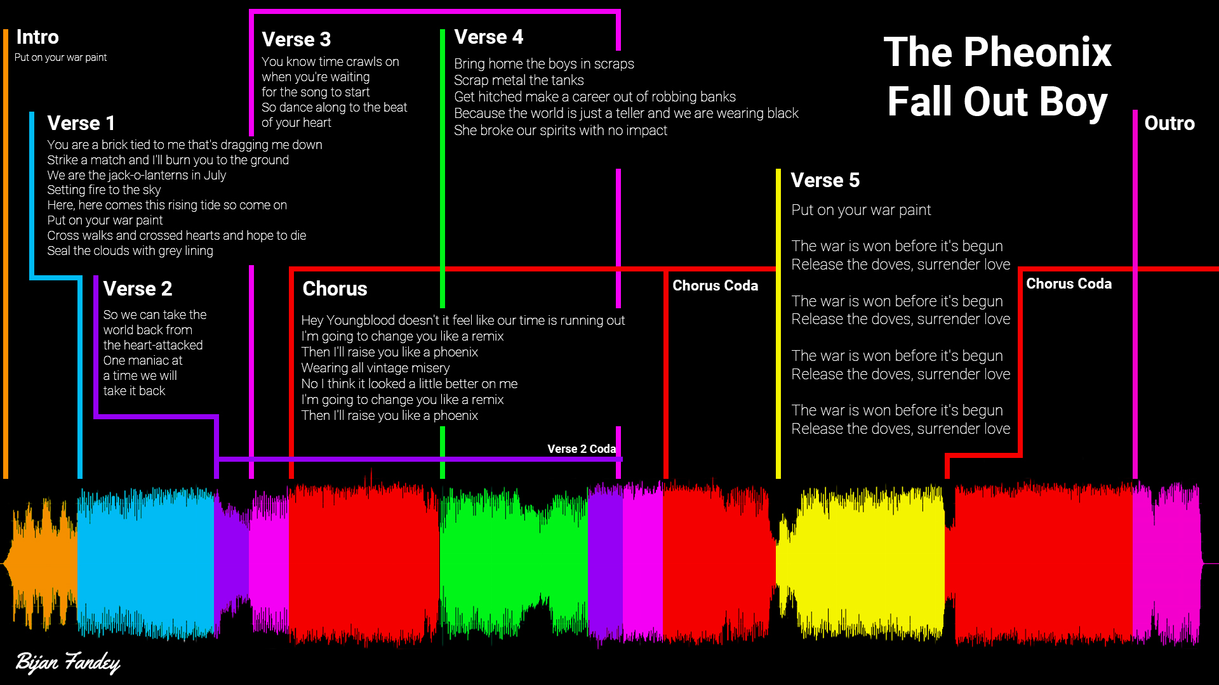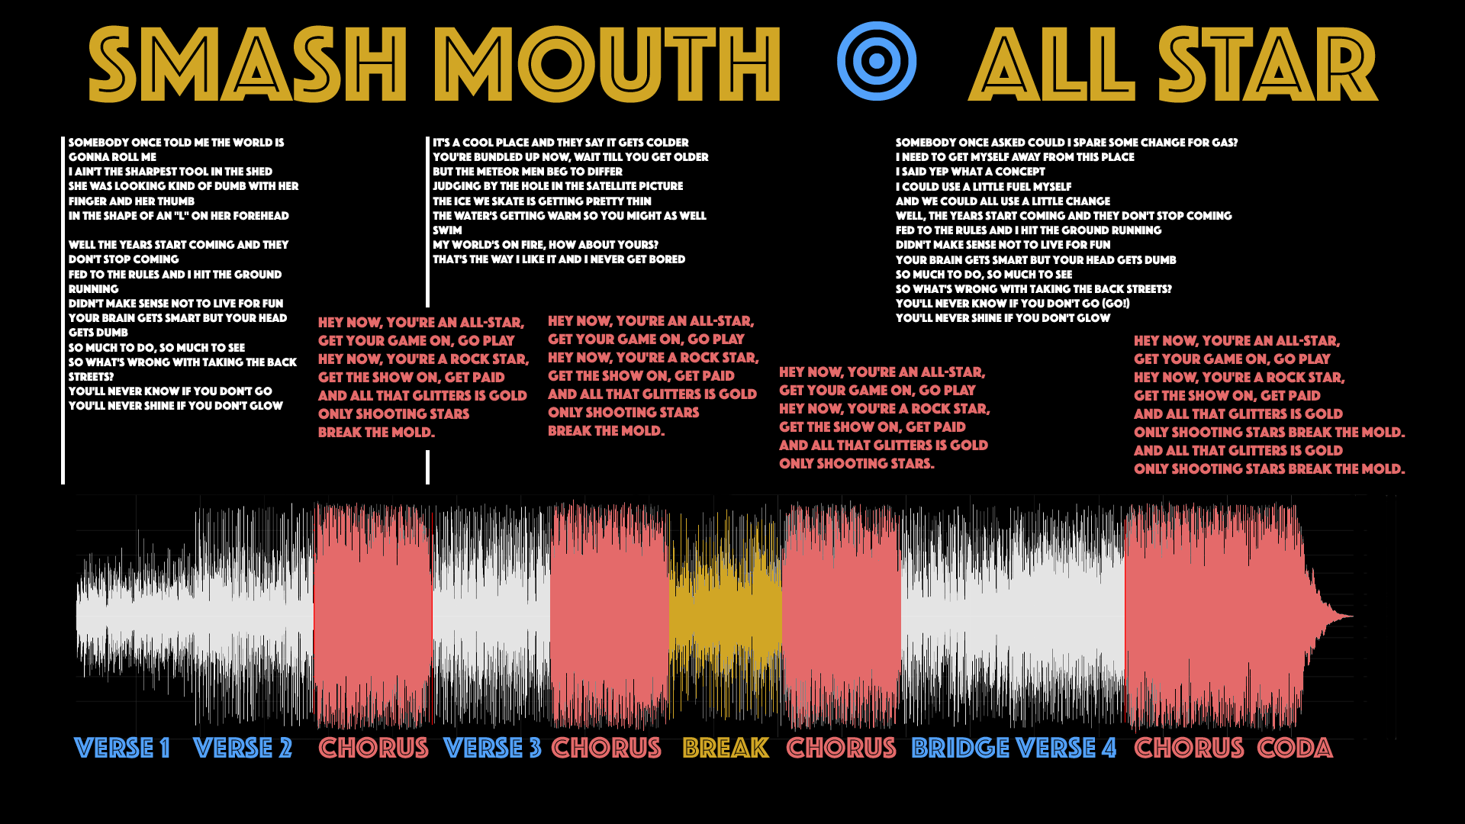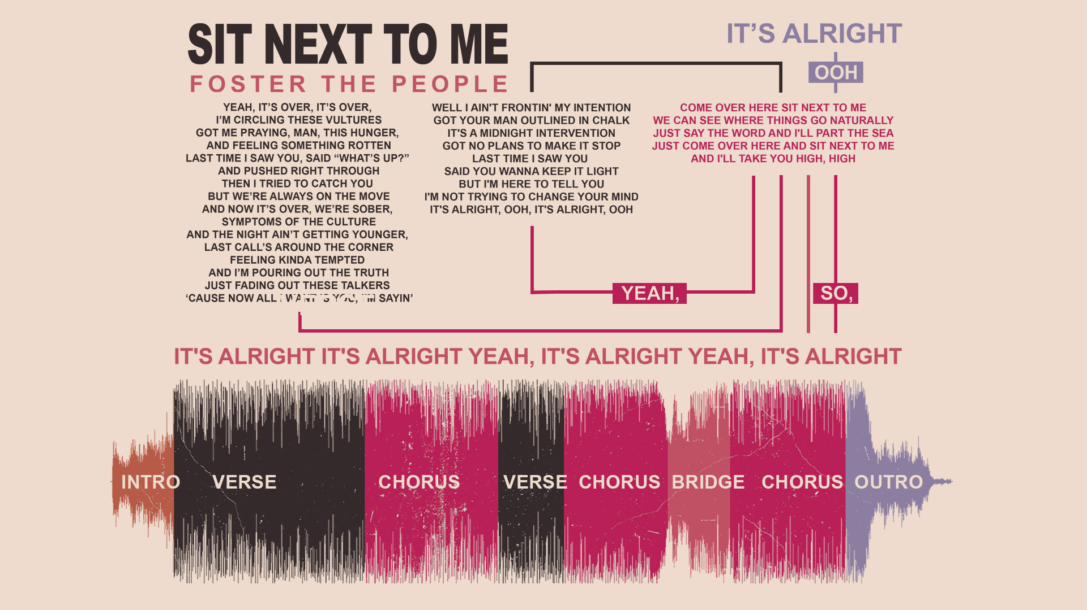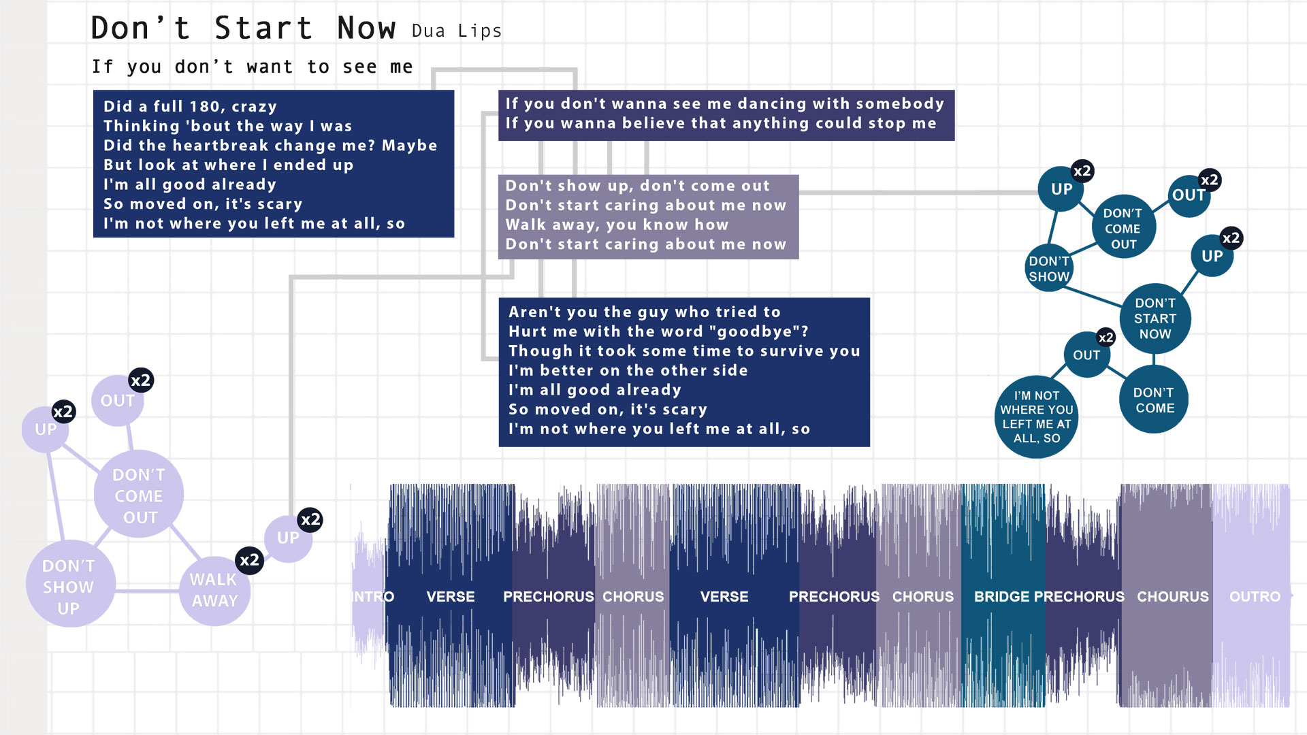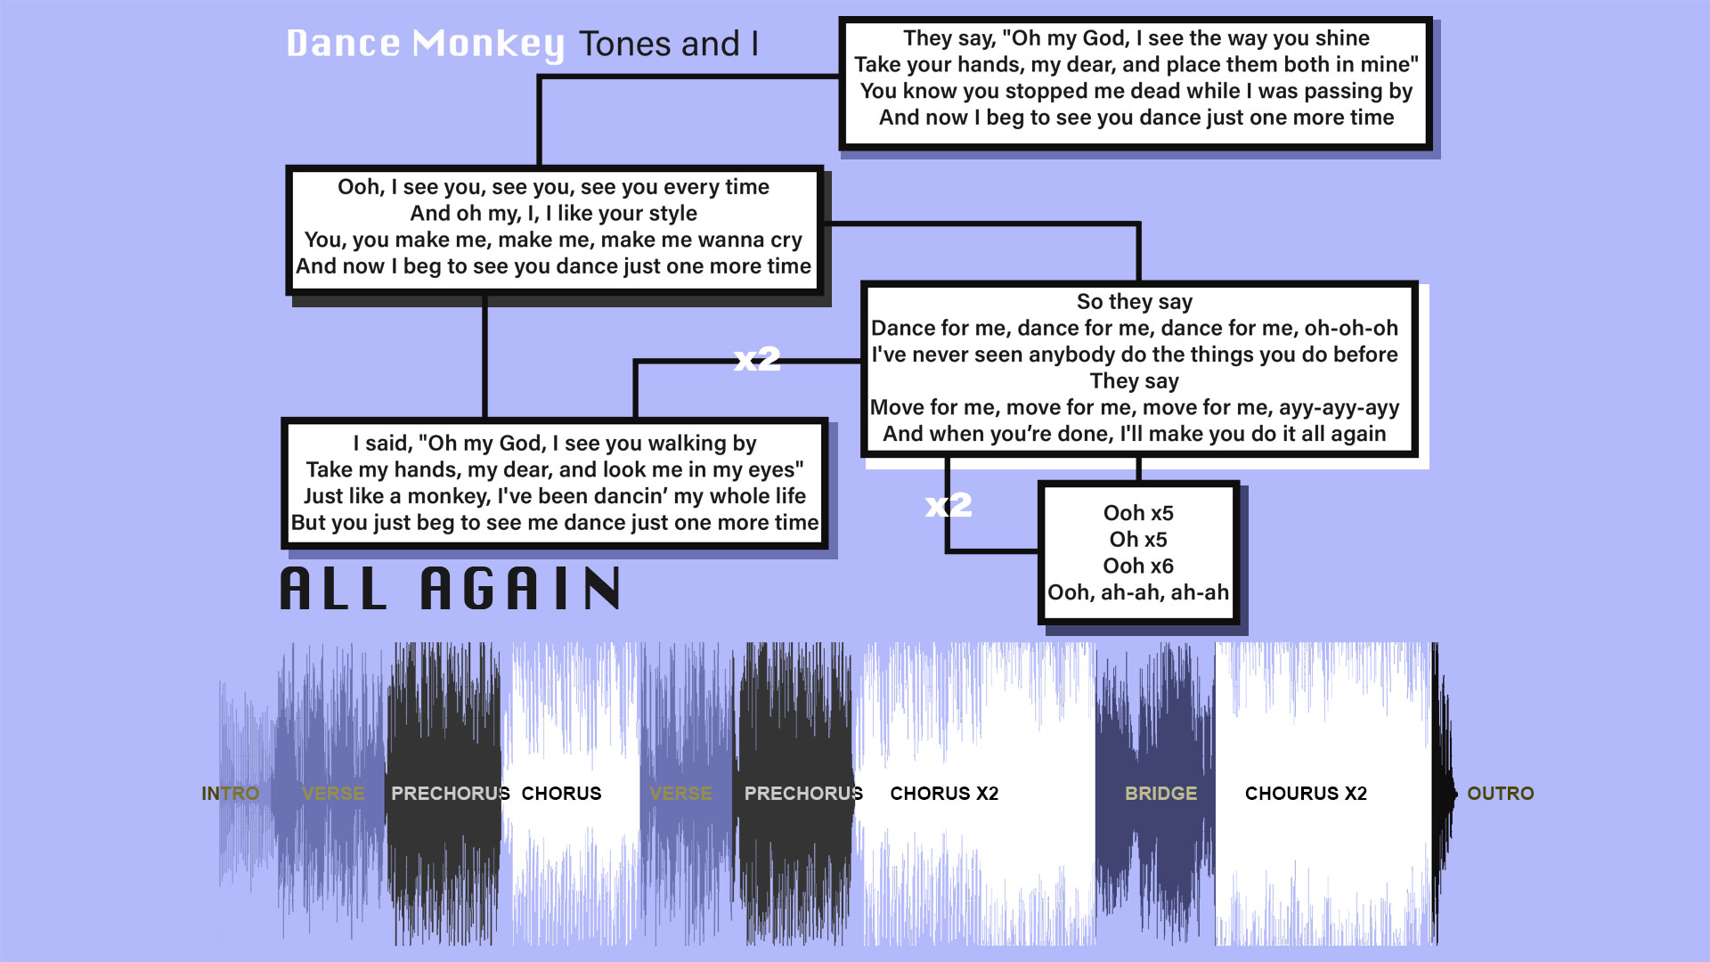

Instructions: Part A
- Select three short songs (max 5 min) and download them.
- Open in Adobe Audition, expand the waveform view, and screen shot each of the waveforms.
- Create a new document, at 960px x 540px, and save as 'SONGNAME_master.jpg".
- Copy one of the three waveforms or your original song from Assignment 3 and paste it.
- Create a headline that includes artist and song name.
- Create a color scheme that accents the song structure identifying each section.
- Transcribe the lyrics and associate the verses, choruses, bridges and breaks with the waveform.
- Use only simple design elements, color, and typography.
- Do not use recognizable imagery, illustration, symbolism, album art, or appropriated images.
- Save the file, and then save a copy as “LASTNAME_a4.jpg”.
- Do not submit this file, you will use it for part B

Instructions: Part B
- Open the audio file for the song that you selected in Audition.
- Select each section of the song and copy to new.
- Save each waveform as a new file, i.e. "1verse.mp3", "2chorus.mp3", "3verse.mp3"
- Open the image “LASTNAME_a4.jpg” in Photoshop.
- Copy and crop each song section to a new image file.
- Save as a new transparent png. i.e. "1verse.png", "2chorus.png", "3verse.png"
- Create a new website folder, named "LASTNAME_a4".
- Download and open ATOM coding app and create a new index.html
- Enter the code from Lesson 4b, making the appropriate changes to position.
- Create a style.css document and enter the code from the Lesson.
- Follow the videos to create your interactive website.
- Compress and submit the website folder to eCampus.

VOCABULARY

Song Structure

Intro

Verse

Chorus

Bridge

Break

Outro

Lyric

Melody

Hook

Rhythm

Tempo

BPM

Arrangement

Remix

